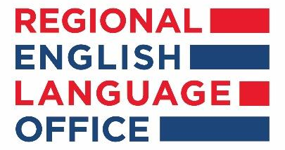

English as a Medium of Instruction Global Online Course
Ohio University |August 23 - November 21
Course Description: English as a Medium of Instruction (EMI) is an online course designed to introduce you to the theory and practice of teaching disciplinary content in English. This course will help you re-develop your existing courses or create new ones that use English as the Medium of Instruction (EMI). Materials include engaging videos, practical readings, and opportunities for collaboration within the course and in your institutions. You will identify challenges that faculty and students encounter in EMI classes and develop strategies for successfully helping students learn course content while simultaneously building or refining their English skills. In addition, you will gain confidence in teaching in English while you also become more comfortable using pedagogies that are interactive and focus on student learning. Topics include course design, syllabi development, lesson and materials creation, teaching interactively in English, and supporting learning through technology. When you complete the course, you will have a portfolio of materials you can use in your own courses.

​By the end of this course, participants will be able to:
- explain the goals, key concepts, challenges, benefits, and current methods in teaching and assessing disciplinary content in English.
- assess your own readiness and comfort with teaching your disciplinary content in English, leading to the creation of your own professional goals.
- identify student needs as they learn disciplinary content in English.
- use effective approaches and techniques appropriate for non-native English-speaking students in EMI courses.
- design lessons that support students’ development of English alongside their learning of course content.
- develop or revise a syllabus and assessments for teaching your disciplinary content in English.
- develop yourself professionally in the field of EMI by participating in an international online learning community and preparing an action or training plan to share your new knowledge and skills with other EMI professionals in your local community.
INSTRUCTIONS:
- Please submit the below form to the International Relations Office of your institution in the deadline set by them.
- Applications sent directly to the Embassy Branch Office in Belo Horizonte will not be consider.
- Save this form as Word document with the Higher Education Institution, candidate name and surname. Examples: UCR_John Smith, UFLA_Joao Silva.
- Delete the instruction information when saving the file with your data.

English as a Medium of Instruction Course application
Fill Name (given name, middle name, family name)
City and Sate of Residence:
Personal Email Address (not institutional)
Phone Number (Area Code + Number). Include WhatsApp Number if available
Name of University/Institution:
Which academic department are you linked to:

 | Please assess your present English language proficiency. (Select one)
Understanding of written English | ☐ Excellent ☐ Good ☐ Fair
Expressing yourself in written English | ☐ Excellent ☐ Good ☐ Fair
Understanding of spoken English | ☐ Excellent ☐ Good ☐ Fair
Expressing yourself in spoken English | ☐ Excellent ☐ Good ☐ Fair
Have you ever taken any English Language Proficiency Test? |  | ☐ Yes ☐ No
If yes, please specify which one (TOEFL, IELTS, Cambridge, other):
Year test was taken:
Score:

